Have your rifle professionally
Bore Sighted…..$60
Scope Mounting…..$40
Lapping (optional)…..$30

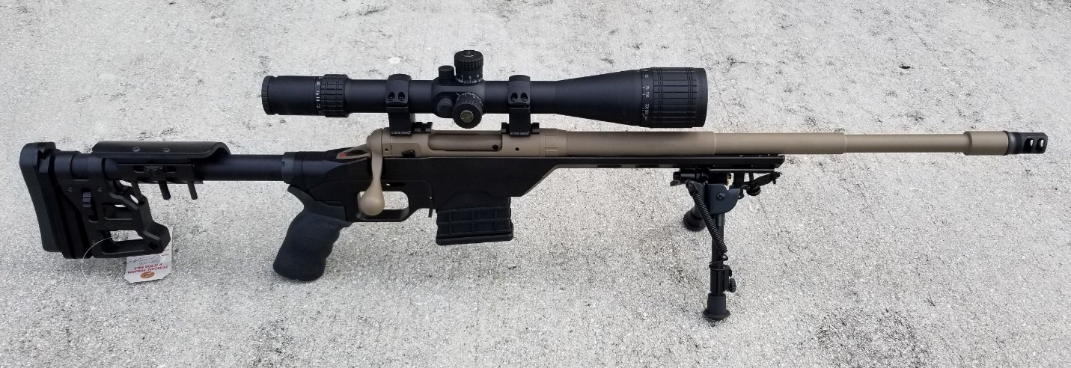

Bore Scoping…..$30

CALL MIKE OR ALISON FOR APPT.
411 TACTICAL
(844) 411-8228

